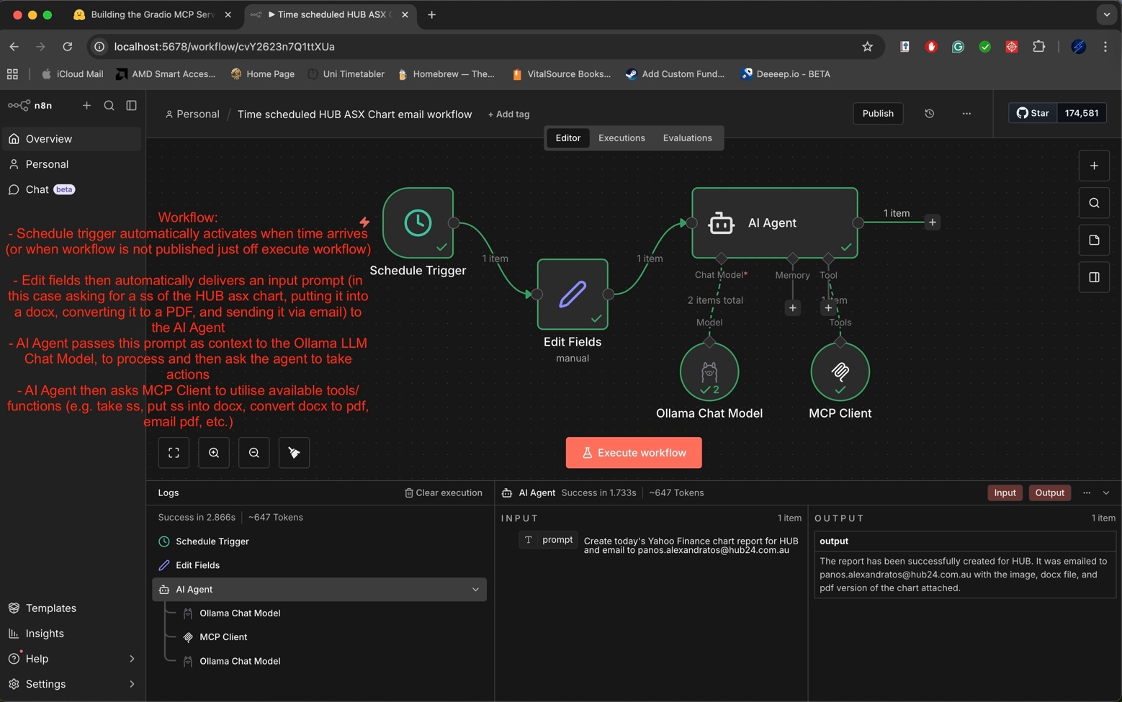
Scheduling prompt for n8n workflow
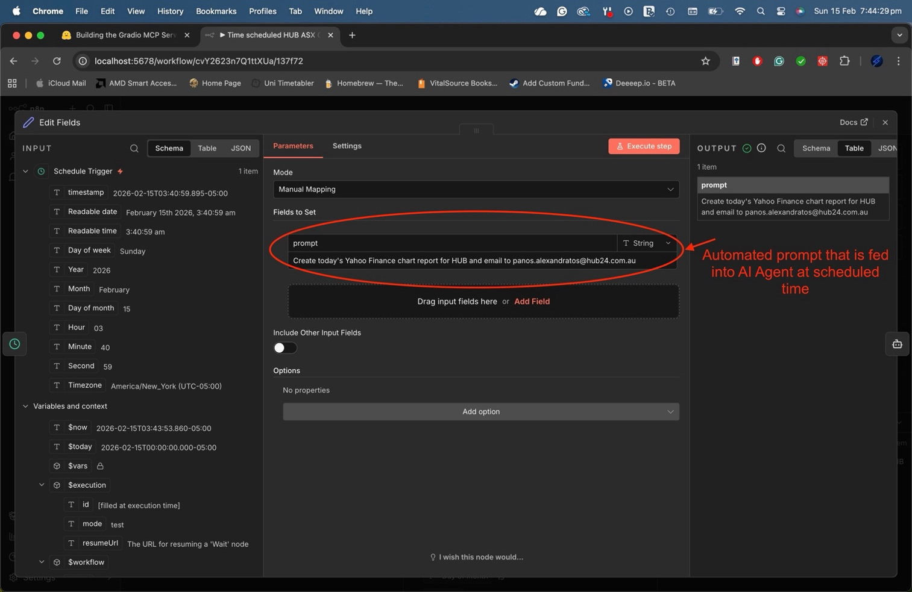
Above is a screenshot showing the n8n workflow to run a prompt through the AI agent to create a brief HUB ASX report, containing a screenshot of HUB’s ASX chart. It works by going to the Yahoo Finance HUB webpage, taking a screenshot of the chart, putting it into a word doc, converting from docx to PDF, and emailing the report to a recipient. Below is the automated prompt.

